AFFECTIVE VIDEO TUTORING SYSTEM
Administrator Manual

To open the administration the Affective Video Tutoring System, use the following steps:
- The system is a part of the BECK Centre developed during the project. Open the BECK project website http://beck-erasmus.com/ to access the system (Fig. 1).
- Go to the BECK project website, select BECK Centre in the menu and click Affective Tutoring System in the drop-down menu (Fig. 1). To start Affective Tutoring System, please refer to the Affective Video Tutoring System Admin Manual.

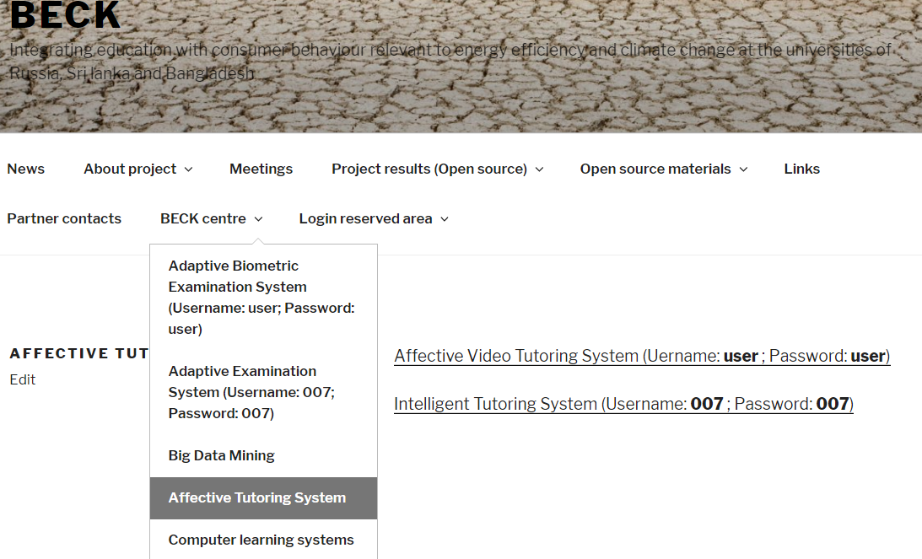
Fig. 1. The BECK project website.

- Use https://beck-smartvideo.com/admin for system administration and creating/editing new/existing surveys. Login details:
  - Username: admin@gmail.com
  - Password: godlike
and click Login (Fig. 2).
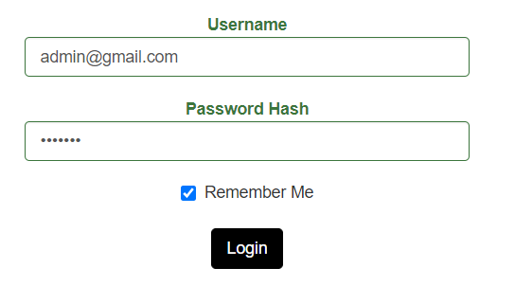
Fig. 2. Administrator login in Affective Video Tutoring System.

1.1. Create a new survey

The steps for creating a new survey are in reverse to the usual order: enter the video link → create an answer → assign video to the answer → create a question → assign an answer to the question → create a survey → assign questions to the survey. Each step is briefly described below.

- Fill in the text matrix and select which video will be uploaded to the system (see the instructions Affective Video Tutoring System video search and matrix creation);
- To add your texts to the system, select Video in the left toolbar (Fig. 3). You can add new video or edit/delete existing video link. Use the following features:
-View
-Update
-Delete
To add new text, click Create video (Fig. 4). A window will open. Enter the title, then copy and paste the video with a reference link and highlighted keywords (Fig. 5). Then click Save.

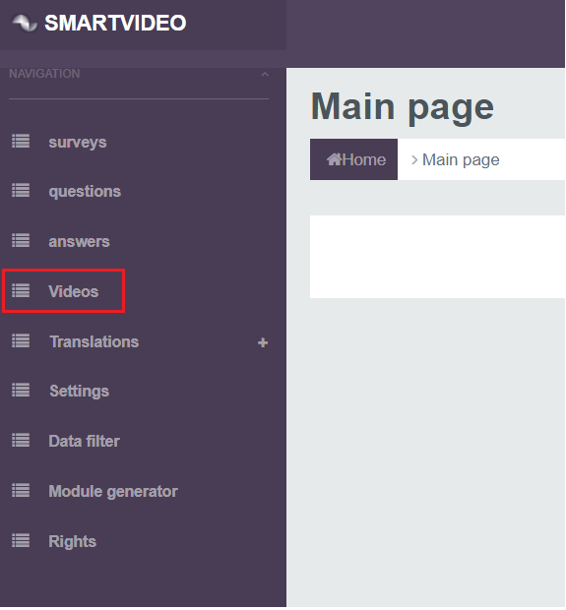
Fig. 3. The button to add text.

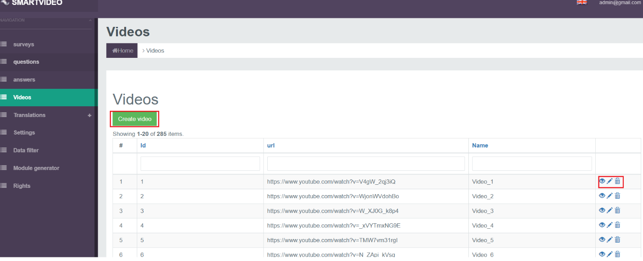`
Fig. 4. The button to add new text.

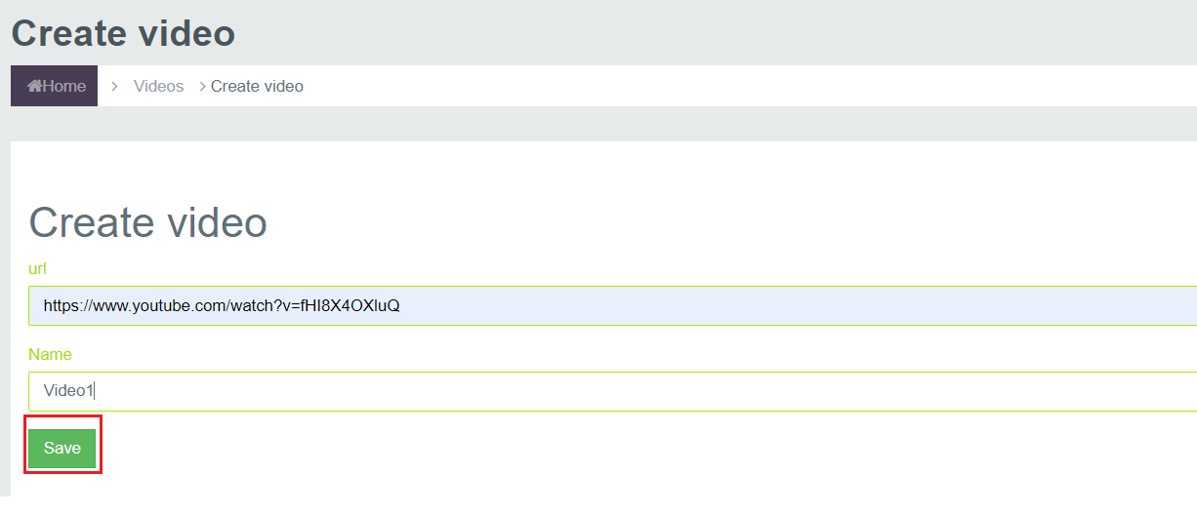
Fig. 5. Uploading new video.

- To add survey answers and assign video, select Answers in the left toolbar. A window will open with the available answers (Fig. 6). Use the following features to review and edit the existing answers:
-View
-Update
-Delete
Click Save when you finish editing. Check the box next to Active (visible to users) to activate or hide answers.
To add a new answer, click Create answer. Add a new answer and click Select video to assign the video you want to the new answer (Fig. 7). Assign the relevant text to the answer taking into account the title of the video. To remove any selected video, click X next to the text. Check the box next to Active to make the answer visible to users.

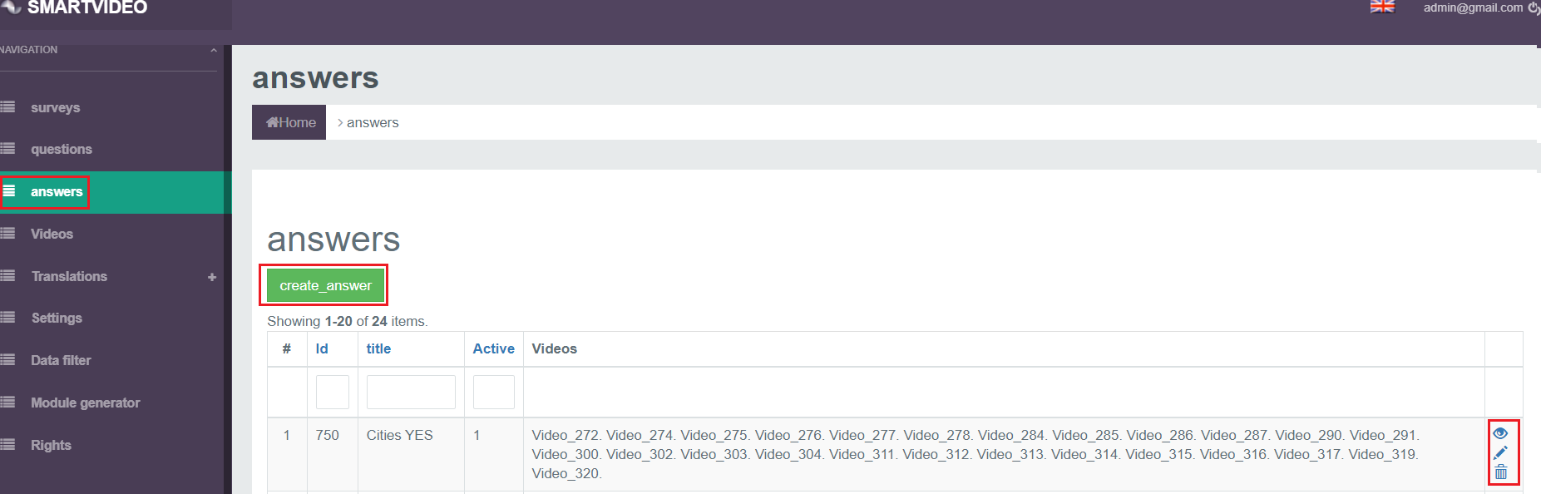
Fig. 6. Creating answers.
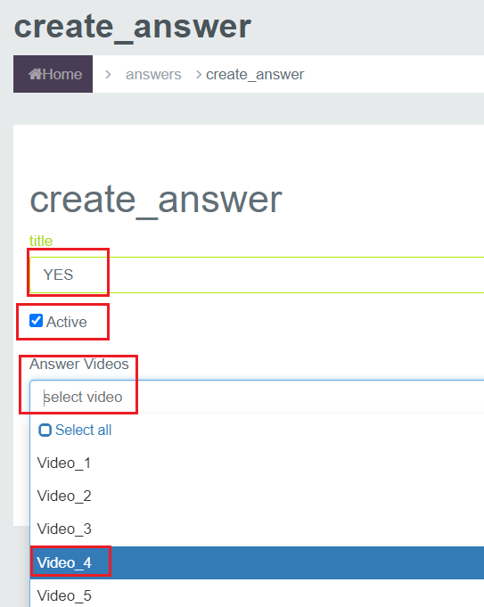
Fig. 7. Adding a new answer and assigning text.

- Add survey questions and assign their answers. A window will open with the available questions and their list (Fig. 8). Use the following features to review and edit the existing questions:
-View
-Update
-Delete
Check the box next to Active to make a question visible to the system users.
To add a new question, select Create_question. Add the question, check the box next to Active to make it visible, assign an answer to the question from the available list and click Save (Fig. 9).

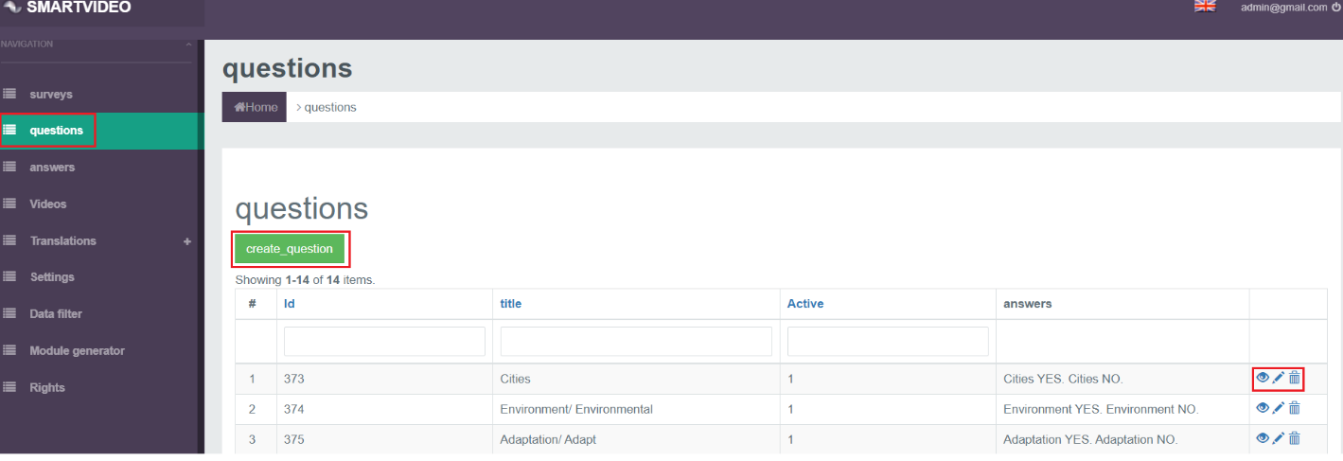
Fig. 8. Creating questions.
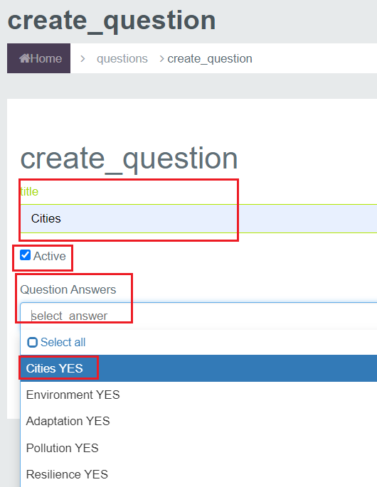
Fig. 9. Adding a new question and assigning an answer.

- Create a survey (Fig. 10), select Survey in the left toolbar. A window will open with the available survey. Use the following features to review and edit the existing survey:
-View
-Update
-Delete
Check the box next to Active to make a survey visible to the system users. To create a new survey, click Create survey. Add the survey title, check the box next to Active to make the survey visible, assign questions to the survey from the available list and click Save.

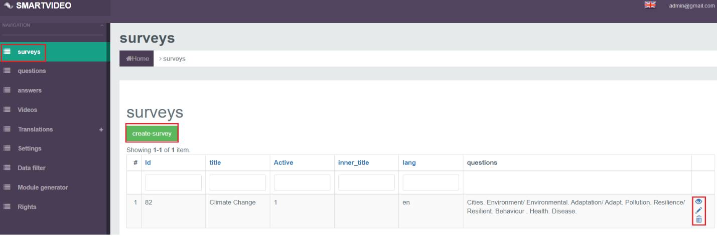
Fig. 10. Creating survey 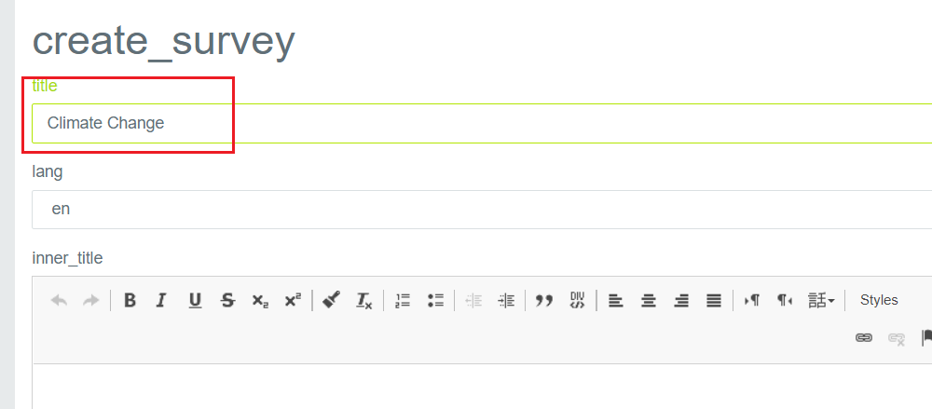
…
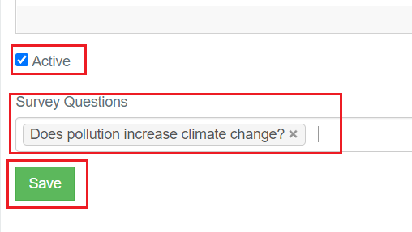
Fig. 11. Adding a new survey and assigning questions.

1.2. Edit an existing survey

- To edit an existing survey or assign video, follow the steps below:
- To edit text, select Video (Fig. 3) in the left toolbar. A window will open with a list of all available videos (Fig. 4). You can add new video or edit/delete existing video. Use the following features:
-View
-Update
-Delete
Click the pencil icon to edit video. A video editing window will be opened. You can edit the title and the video link. Click Save to save your adjustments.
- To edit existing answers, select Answers (Fig. 6) in the left toolbar. A window will open with a list of available answers. You can add new answers or edit/delete existing answers. Use the following features:
-View
-Update
-Delete
Check or uncheck the box next to Active to activate or hide answers. Click the red dot highlighted in Fig. 12 to assign more video to an answer. A menu with all available video will open automatically. To add more content, select the video you want to add. To delete an assigned video, click X next to the video you want to delete. When you finish editing, click Save.

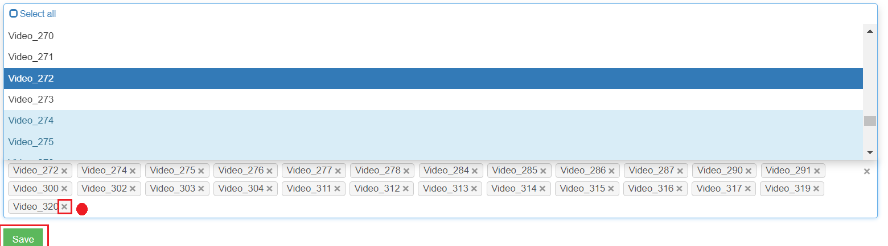
Fig. 12. Assigning or deleting additional text.

- To edit existing questions, select Questions (Fig. 8) in the left toolbar. A window will open with a list of available questions. You can add new question or edit/delete existing questions. Use the following features:
-View
-Update
-Delete
Click the red dot highlighted in Fig. 13 to assign more answers to a question. A menu with all available answers will open automatically. To add more answers, select the answer you want to add. To delete an assigned answer, click X next to the answer you want to delete. When you finish editing, click Save.

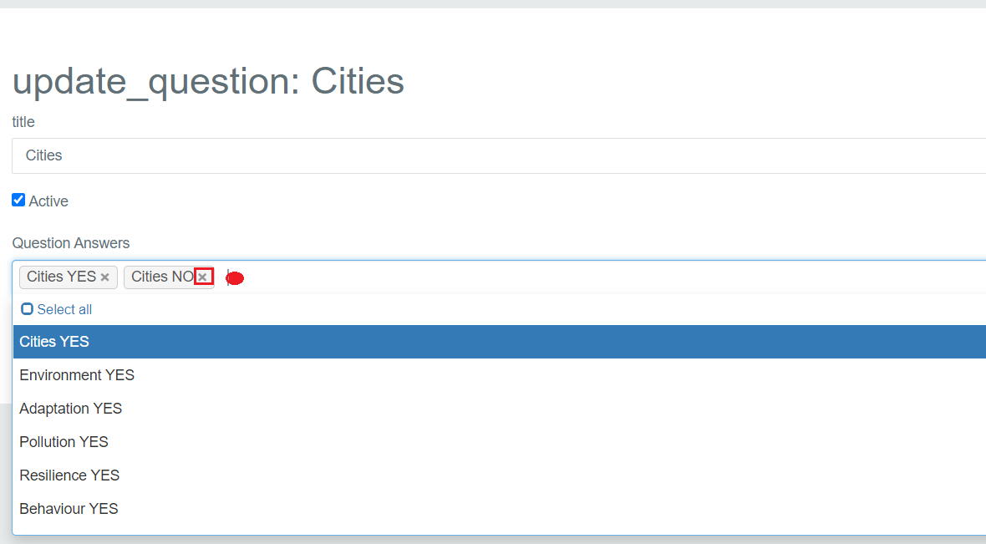
Fig. 13. Assigning or deleting additional answer.

- To edit existing survey, select Survey (Fig. 10) in the left toolbar. A window will open with a list of available surveys. You can add new survey or edit/delete existing surveys. Use the following features:
-View
-Update
-Delete
Click the pencil icon to edit survey. Check or uncheck the box next to Active to activate or hide survey. You can edit the title and the survey. Click the red dot highlighted in Fig. 14 to assign more questions to a survey. A menu with all available questions will open automatically. To add more content, select the questions you want to add. To delete an assigned question, click X next to the question you want to delete. When you finish editing, click Save.

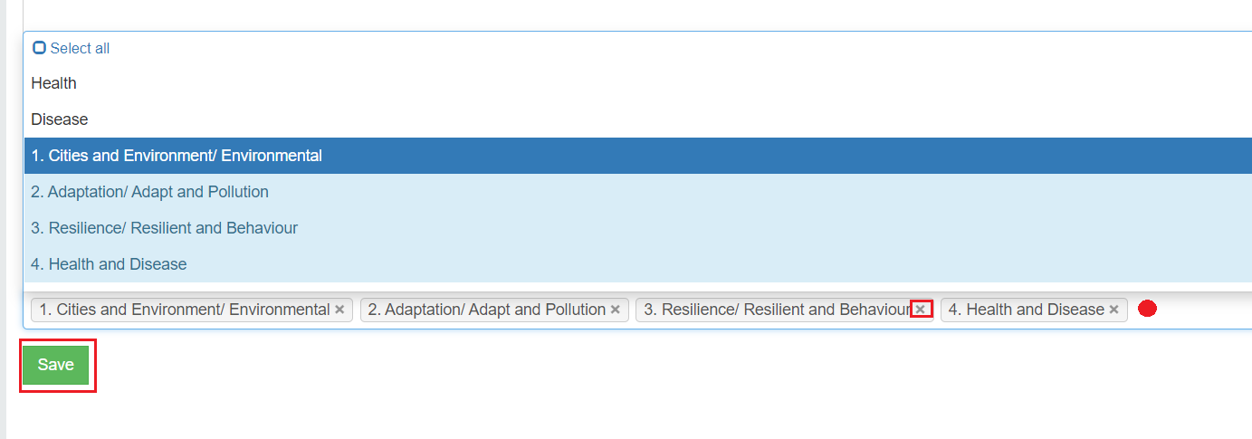
Fig. 14. Assigning or deleting additional question.

Other system features
- Parameters. This option lets you set a delay. This means you can set the time to start the analysis of a user’s emotions when a video is opened. The interval for tracking and recording the viewer’s emotions can be also set. 1,000 = 1 second. Set the parameters and click Save (Fig. 15).
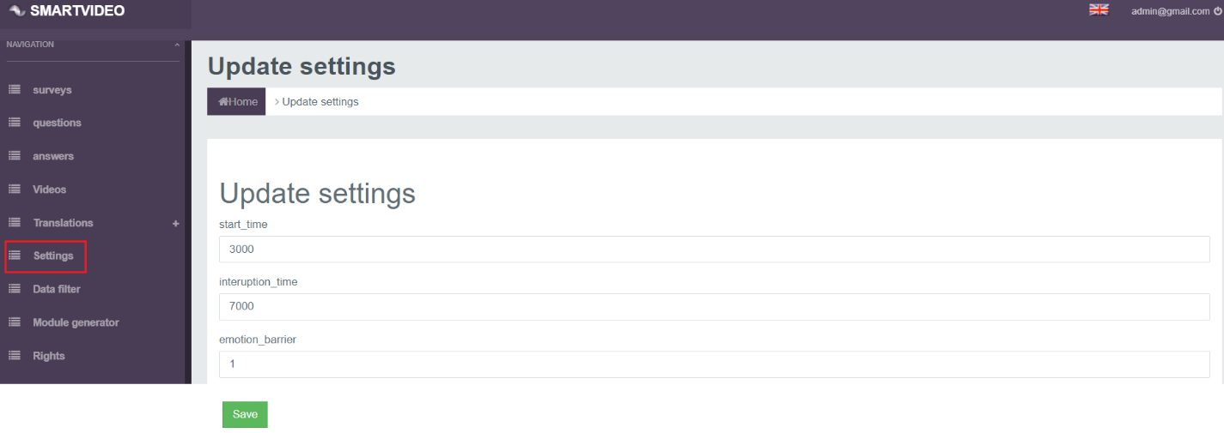
Fig. 15. The analysis settings window.

- Data filtering. This option lets you see the emotions determined for the selected time period (click the calendar icon). Set the year, month, day, hour and minute and then click Filter (Fig. 16).

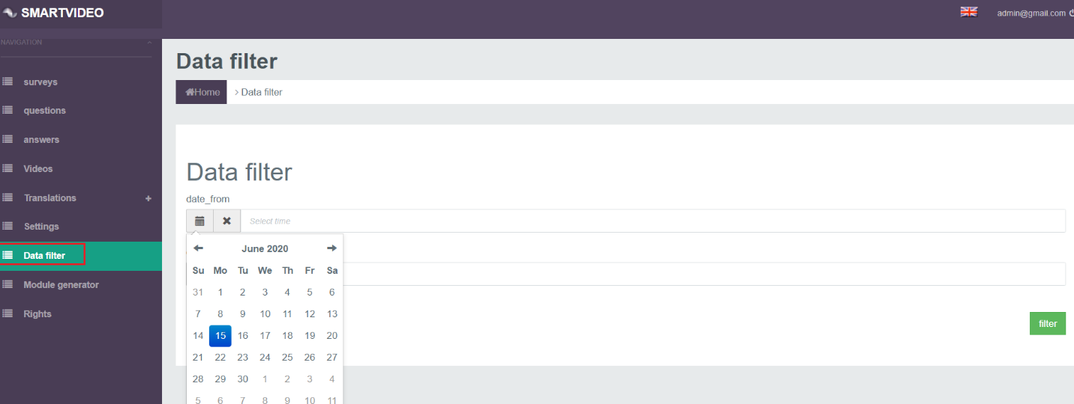
Fig. 16. Data filtering window.

This option also shows the data for the selected time period (Fig. 17)

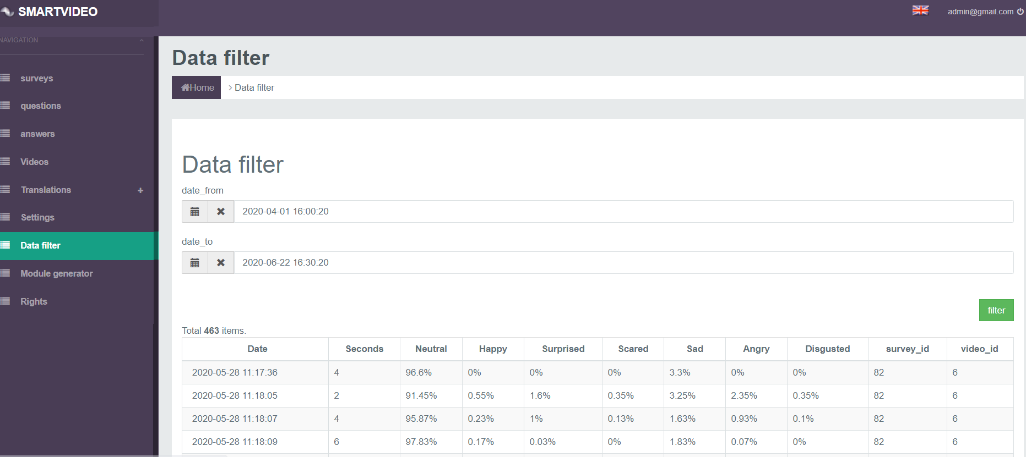
Fig. 17. Data for the selected time period.

